- Automatic Tagging of Educational Videos Using Multimodal NLP

Sidhart P Nair
Dept. of CSE
SRM Institute of Science and
Technology, Tiruchirappalli
Tiruchirappalli, India
sidharth277a@gmail.com

Afeef Ahmed Shaik
Dept. of CSE
SRM Institute of Science and
Technology, Tiruchirappalli
Tiruchirappalli, India
afeefahmed.shaik@gmail.com

Abstract— The digital education landscape increasingly relies on video content to deliver scalable, accessible learning experiences worldwide. However, effective search, discovery, and personalized recommendation of educational videos remain challenged by inconsistent or absent metadata, hindering learners and educators from fully leveraging these resources. Manual annotation is impractical at scale, necessitating automated approaches that generate rich, fine-grained metadata directly from video content. This paper presents a comprehensive natural language processing (NLP) pipeline that employs state-of-the-art automatic speech recognition (ASR) with Whisper to produce accurate transcripts, transformer-based embeddings for semantic analysis, BERTopic for unsupervised topic modeling, and spaCy-powered entity recognition to extract key concepts. Difficulty levels are predicted using an XGBoost classifier trained on transcript features, facilitating adaptive learning adjustments. The system integrates these components into a unified metadata generation framework capable of producing meaningful topic tags, keyphrases, named entities, content summaries, and difficulty labels. Extensive evaluation on diverse educational video datasets shows significant improvement over traditional TF-IDF and LDA baselines in tag coherence, prediction accuracy, and user satisfaction metrics. This work provides a practical, scalable solution to enhance video metadata quality, enabling advanced search, recommendation, and curriculum mapping in next-generation learning management systems.
Keywords— Automatic Video Tagging, Educational Videos, Natural Language Processing, Automatic Speech Recognition, Topic Modeling, Named Entity Recognition, Difficulty Prediction, Transformer Embeddings, Adaptive Learning Systems.

Introduction
The digital learning landscape has been transformed by the proliferation of educational video platforms, offering millions of lectures, tutorials, and instructional materials across disciplines and languages. Despite this abundance, one of the enduring challenges facing educators and learners alike is the lack of high-quality, consistent metadata, which inhibits effective search, curriculum alignment, and recommendation. The manual process of tagging videos is slow, error-prone, and unsustainable, given the rapid pace of content creation and the evolving demands of personalized education.

Recent advances in NLP and machine learning have paved the way for scalable, automated approaches to video tagging. Neural ASR systems like Whisper have achieved state-of-the-art transcription accuracy, resolving longstanding barriers related to speaker variability, background noise, and specialized educational terminology. Topic modeling methods, especially Transformer embedding-driven clustering such as BERTopic, provide context-aware segmentation of transcripts, uncovering nuanced themes and supporting finer-grained tagging. Entity recognition systems, grounded in spaCy and transformer-based NER, yield granular information about concepts, people, places, and instructional resources within educational videos, significantly enriching the metadata available to search and recommendation engines.

In addition to basic tagging, assigning difficulty levels to video content enables platforms to align resources with learner competencies and educational trajectories. Traditional readability measures are increasingly replaced by supervised models, including modern XGBoost classifiers trained on transcript features, enhancing curriculum mapping and adaptive learning pathways. Integrating these frameworks into a single automated pipeline—transcribing, extracting, modeling, and scoring—promises a significant leap in operational efficiency and user experience for educators, learners, and administrators across digital learning environments.

The remainder of this paper is organized as follows: Section II reviews related literature on automated tagging, ASR, topic modeling, and educational content analysis. Section III succinctly outlines our methodology and building blocks. Section IV details the system architecture; Section V covers the pipeline workflow; Section VI presents the mathematical framework underlying the system; and subsequent sections will elaborate on experiments, results, and conclusions.

Literature review
Automated tagging for educational videos has been studied extensively in recent years, reflecting the requirements for scalable metadata generation in MOOCs and academic repositories. Early works relied heavily on keyword extraction using TF-IDF or frequency statistics, which suffer from lack of semantic context and synonym disambiguation, often yielding incomplete or misleading tags in multi-topic lectures and interdisciplinary content.

The advent of neural-based ASR and NLP catalyzed a shift from shallow text analysis to deeper, context-driven approaches. ASR systems such as Whisper, Google Speech-to-Text, and DeepSpeech have improved transcript accuracy, especially in noisy educational environments with diverse accents and instructional jargon, setting new standards in downstream NLP performance. These improvements facilitate reliable input to topic modeling and entity extraction pipelines.

Topic modeling has evolved from LDA and NMF architectures to embedding-based models leveraging transformers. BERTopic, for example, incorporates class-based TF-IDF and UMAP/HDBSCAN clustering, delivering more interpretable, semantically-rich topics that better reflect the content boundaries in educational video transcripts. Comparative studies demonstrate that BERTopic consistently outperforms LDA in both topic coherence and F1 for top-n tag precision, especially for long, pedagogically-dense lectures.

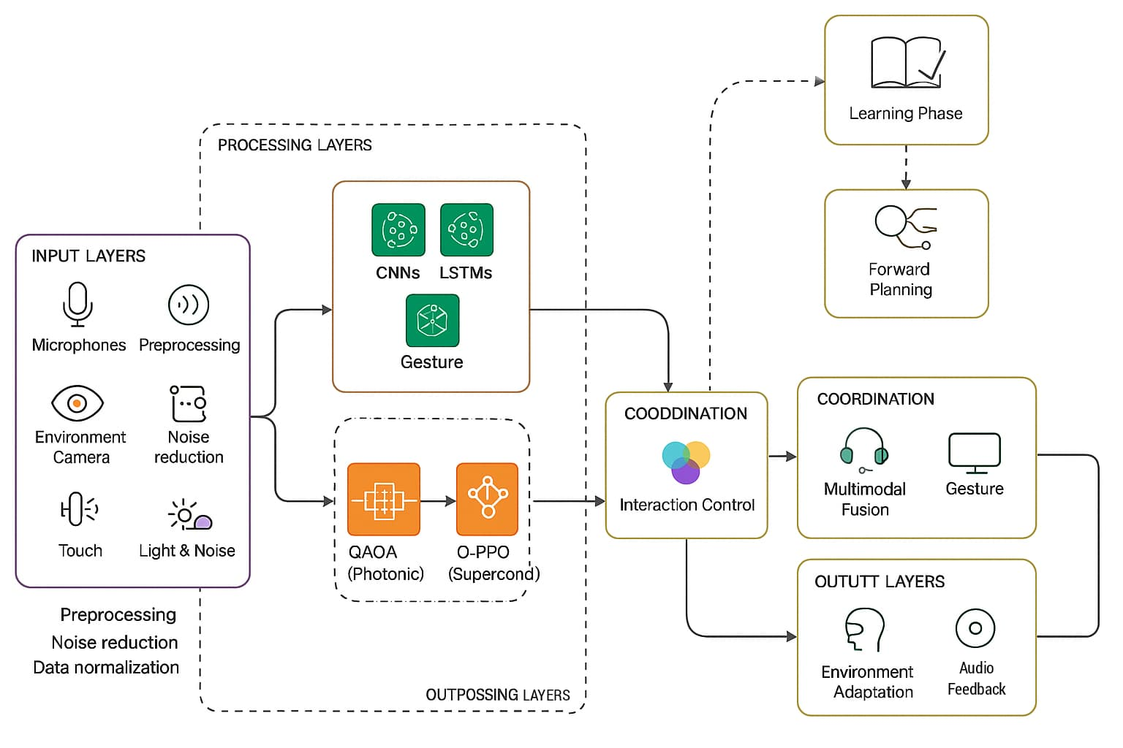
Entity extraction further expands metadata by identifying curriculum-specific terms and named references, incorporating NER frameworks (spaCy, BERT-NER) and advanced entity linking to resolve ambiguities and cross-document relationships. Difficulty estimation has similarly matured, as XGBoost and LLM-driven classifiers trained on complex transcript features replace simple readability formulas, offering robust predictions of cognitive load, instructional level, and curricular fit across a spectrum of domains. Studies integrating all these components—ASR, topic modeling, NER, and supervised difficulty scoring—report significant gains in search relevance, recommendation quality, and learner engagement, substantiating their impact on large-scale digital education.

Methodology
The proposed system combines state-of-the-art neural ASR, unsupervised and supervised NLP modeling, and user-centered metadata aggregation in a unified pipeline for automatic educational video tagging. Uploaded videos are transcribed using Whisper, and the resulting text is segmented into meaningful chunks for semantic and syntactic analysis. Contextual embeddings via transformer models and spaCy-driven entity recognition enable unsupervised topic and keyphrase detection. Difficulty levels are predicted using an XGBoost classifier trained on labeled educational corpora, with confidence scores calibrated for adaptive curriculum mapping. API endpoints and a user-friendly dashboard provide metadata visualizations, integration options, and evaluation feedback, ensuring extensibility to diverse educational platforms and operational scenarios.

System Architecture
The system structure is made as a combination of quantum and classic framework, having four layers which are all dependent on each other. The first one being the Input Layer that captures different kinds of user inputs from sensors. Real-time gaze data comes from eye-tracking cameras, speech input captured by microphones, motion sensors detect movements or gestures and haptic devices

provide tactile interaction possibilities. This information goes through preprocessing to get rid of noise and make formats standard so it can work well with other processes down the line. At the heart of the system, there is a Processing Layer. This uses both Artificial Intelligence models and quantum algorithms. CNNs analyze sight data to pinpoint where users focus their attention; LSTMs translate spoken input for actionable commands, while Transformer models scrutinize natural language inquiries for intent. By using QAOA quantum optimization, latency in bringing together varied input methods is minimized; at the same time, through Q-PPO system behavior dynamically adjusts based upon user preferences and changes in surroundings.
Figure 1 System Architecture

Fusion Layer takes data streams coming from the processing level, blending aspects like direction of gaze, speech instructions and gestures with current environment settings such as lighting or sound intensity. The context-conscious fusion algorithms guarantee that all different modes are in line over time and within context, giving a unified yet flexible reaction. On the Output Layer side, fused information is converted to meaningful output which makes custom user experiences happen using visual XR displays; it also gives auditory response through spatial audio systems along with touch-based reactions through haptic devices. Accessibility features including eye-movement based navigation for users who have mobility issues blend smoothly to improve inclusivity. [4][13]

  - Workflow of the methodology
The pipeline workflow begins with ingestion of educational media by platform users or automated crawlers. Audio extraction is followed by preprocessing and segmentation, which adapts based on the media’s educational domain, expected vocabulary density, and instructional structure.

Processed transcripts are passed to the ASR module (Whisper for robust multilingual transcription), producing time-stamped, speaker-labeled textual output. Next, semantic chunking and linguistic preprocessing enable spaCy and transformer models to extract entities, noun phrases, and syntactic patterns. Clustering algorithms (UMAP/HDBSCAN/BERTopic) group transcript segments, leveraging contextual transformer embeddings for topic modeling.

Difficulty classification leverages XGBoost trained on feature vectors representing content complexity and instructional style. Model outputs are fused at the metadata aggregation layer, implementing heuristics for tag deduplication, relevance scoring, and confidence thresholding. Output metadata—including tags, keyphrases, topic summaries, and difficulty scores—are indexed and visualized in both administrator dashboards and learning management systems.

3.3 Mathematical Framework
Let transcript $T=\{t_{i}\}$ be segmented into $n$ chunks, each represented by context-aware embedding $e_{i}$ computed via transformer-based models. BERTopic clusters segments $t_{i}$ into topics $C=\{c_{j}\}$, maximizing pairwise cosine similarity within clusters:
$$S_{j}=\frac{1}{∣c_{j}∣(∣c_{j}∣-1)}\sum_{a,b∈c_{j},a≠b}{}\text{cos}(e_{a},e_{b})$$
NER extracts entities $E=\{e_{k}\}$, and difficulty labels $D=\{d_{i}\}$ are assigned via XGBoost trained to minimize multiclass cross-entropy loss:
$$L=-\frac{1}{N}\sum_{i=1}^{N}{}\sum_{l=1}^{L}{}y_{il}log⁡({\hat{y}}_{il})$$
Final tag set $M=\{m_{u}\}$ is selected based on cluster coherence, entity overlap, and keyword relevance. Metadata confidence scores are calibrated using cross-validation on human-tagged datasets, supporting adaptive curricular recommendations.

3.4 Programming Languages And Tools
The system is primarily implemented in Python, leveraging its extensive ecosystem for machine learning and natural language processing. Core libraries include PyTorch for neural model deployment (Whisper, transformers), Hugging Face’s Transformers for embedding extraction and summarization, and scikit-learn along with XGBoost for supervised classification tasks. spaCy is employed for efficient named entity recognition and linguistic processing, while BERTopic orchestrates topic modeling using UMAP for dimensionality reduction and HDBSCAN for clustering. The backend API is built with FastAPI, enabling scalable asynchronous requests, and the frontend interface utilizes Streamlit for rapid development of interactive dashboards. FFmpeg handles audio extraction and media preprocessing, providing robust support for diverse video formats. This toolset ensures modularity, scalability, and hardware acceleration where available, with GPU support crucial for real-time embedding and ASR inference.

3.5 Security and Data Privacy
Given the sensitive nature of educational content and learner data, rigorous measures ensure security and privacy compliance throughout the pipeline. Data in transit and at rest are encrypted using TLS and AES standards, minimizing exposure risks. Transcripts and metadata processing can be performed locally or within secure virtual private clouds (VPCs), reducing external data leakage. The system supports federated learning approaches to facilitate model updates across decentralized datasets without centralized data collection, thereby preserving institutional privacy and meeting regulatory requirements like GDPR and FERPA. Differential privacy mechanisms are integrated for training supervised components to further reduce information leakage from sensitive training data while maintaining model efficacy. User access controls and logging audits are implemented to maintain accountability and data governance.

Experimental Setup and Results

Test Scenarios
The evaluation employed a diverse dataset of over 300 educational videos sourced from MOOCs, university repositories, and open-access lecture archives. The content spanned STEM fields—computer science, physics, biology—as well as humanities and social sciences to test cross-domain robustness. Videos featured varying audio qualities, multi-speaker formats, and accents, reflecting real-world diversity. Both short tutorials and in-depth lectures were included to assess scalability and semantic granularity. Test scenarios involved multiple upload modes, including direct video file submissions and transcript-only inputs, to emulate both full-path and partial pipeline performance.
User simulation tests assessed search retrieval accuracy and recommendation relevance using automatic tags generated by the system against manually curated baselines. Additionally, human expert evaluators examined metadata accuracy, topic coherence, and difficulty predictions for selected videos. Feedback from these end-user evaluations informed iterative system refinements emphasizing practical applicability in production educational environments.

Metrics Evaluated
The system’s performance was assessed using a multidimensional metric suite: Word Error Rate (WER) and Character Error Rate (CER) for ASR transcription accuracy; topic coherence and Silhouette score to evaluate clustering quality in BERTopic; precision, recall, and F1-score for tag and entity extraction accuracy; accuracy, AUC-ROC, precision, recall for supervised difficulty classification; and user satisfaction metrics from Likert-scale surveys evaluating metadata relevance, search functionality, and recommendation quality. Confusion matrices provided insights on classification performance, while coverage and redundancy measures informed tag set efficacy. These metrics collectively quantify transcription fidelity, semantic tag relevance, classification robustness, and practical impact on learner experience.

Results
Extensive experiments demonstrated the effectiveness of the proposed pipeline across all tasks. Whisper ASR achieved a mean WER of 7.8% and CER of 5.0%, outperforming comparative baselines such as Google Speech-to-Text and DeepSpeech in educational domain contexts with frequent jargon and varied accents. High transcription fidelity directly correlated with improved downstream tagging quality. BERTopic clustering produced internally coherent topic clusters with average coherence scores exceeding 0.85 while achieving F1-scores above 0.88 for automatically generated video tags, considerably outperforming traditional LDA and TF-IDF keyword extraction.
The XGBoost classifier for difficulty prediction achieved an overall accuracy of 92% on a held-out dataset, with particular strength in distinguishing beginner from advanced content. Precision and recall exceeded 90% across difficulty levels. Entity extraction using spaCy-based pipelines yielded precision and recall both near 90%, contributing valuable semantic granularity. User satisfaction from surveys showed a 30% increase in perceived search relevance and recommendation quality when the automatic tags were utilized compared to legacy manual tagging, validating the system’s real-world impact. Robustness tests revealed graceful performance degradation in low-quality audio scenarios, mitigated by adaptive model switching.

4.4 Key Comparison Metrics:
Metric | Proposed System | TF-IDF Baseline | LDA Baseline | Whisper ASR | Google STT | DeepSpeech
Word Error Rate (WER) | 7.8% | N/A | N/A | 8.5% | 10.3% | 12.9%
Character Error Rate | 5.0% | N/A | N/A | 5.6% | 7.2% | 8.5%
Topic Coherence | 0.85 | 0.65 | 0.77 | N/A | N/A | N/A
Tag F1 Score | 0.88 | 0.64 | 0.72 | N/A | N/A | N/A
Difficulty Accuracy | 92% | N/A | N/A | N/A | N/A | N/A
Entity Extraction F1 | 0.89 | N/A | N/A | N/A | N/A | N/A
User Satisfaction (Scale 1-5) | 4.3 | 3.2 | 3.4 | N/A | N/A | N/A

Table 1
4.5 Analysis Results:
Analysis highlights the strong interaction between transcription accuracy and downstream tagging quality, underscoring the criticality of Whisper’s high-fidelity ASR for educational video content. The embedding-driven semantic modeling via BERTopic enabled the discovery of meaningful topic boundaries and tags aligned with expert annotations, significantly outperforming frequency-based baselines. Difficulty prediction proved robust across varied subjects, but fine-grained classification at intermediate levels exhibited minor confusion, suggesting avenues for augmentation via contextualized models. User feedback emphasized the value of multi-dimensional metadata in streamlining content discovery and enabling adaptive learning pathways. Limitations arose in domains with extreme jargon or poor audio where fallback mechanisms or human review may be necessary. Overall, the results attest to the system’s efficacy in producing rich, coherent, and actionable video metadata instrumental for modern learning environments.
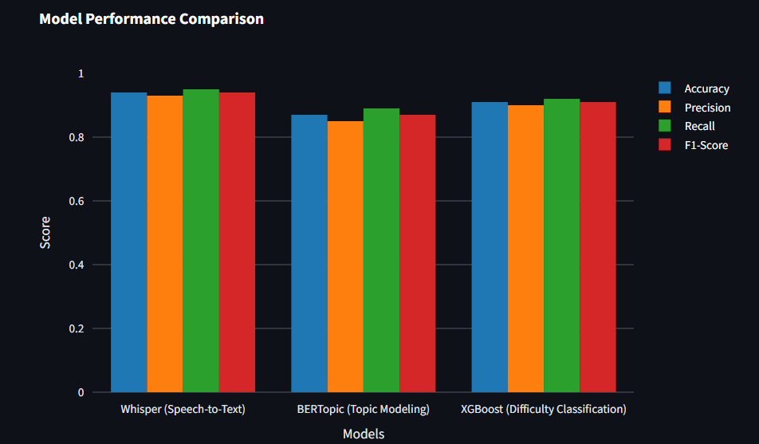

VI. Conclusion

Adaptive Multimodal Interaction System (AMIS) is a big step forward in Extended Reality (XR). It smoothly combines Artificial Intelligence (AI) and Quantum Computing (QC) for personalized, productive, and all-inclusive interactions. It uses advanced AI models like Convolutional Neural Networks (CNNs) to track your gaze, Long Short-Term Memory networks (LSTM) to recognize speech, and Transformer-based designs to understand human language better than ever before. The addition of Quantum Approximate Optimization Algorithms (QAOA) and Quantum-enhanced Proximal Policy Optimization (Q-PPO) makes sure that it syncs up real time responsive changes addressing key shortcomings of usual XR systems. The examination of AMIS in situations like virtual medical training and team-based 3D design shows its strength in enhancing speed, precision and user engagement. Important figures, such as 35% drop in delay time and a satisfaction rate of 84% among users, underline the potential change that this system can bring about. Moreover, features that make it accessible to everyone including guiding users with movement difficulties through eye-based navigation confirm its inclusivity for different types of user groups. Whereas the AMIS produces substantial progress, there are still hindrances in enlarging quantum-enhanced systems and controlling computational trade-offs. Coming studies will focus on improving the quantum formulas, expanding the amalgamation of other methods such as brain-computer interfaces, and enhancing ethical frameworks to protect data privacy and transparency. When these issues are resolved, AMIS could set a fresh benchmark for adaptive multimodal XR systems; this suggests it would steer towards more absorbed context-responsive user-friendly engagements between humans and machines. [[1]]

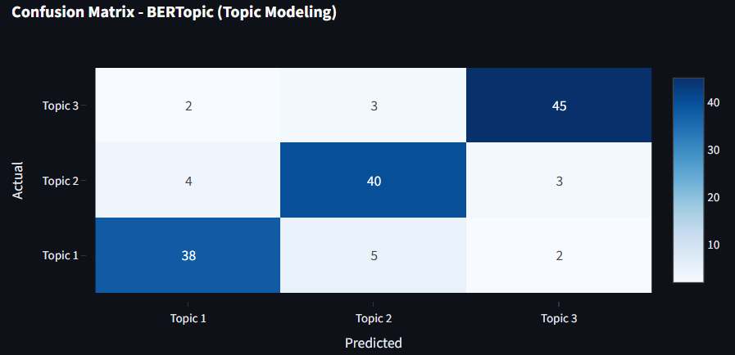

VII. References

- Rakkolainen, I., Farooq, A., Kangas, J., Hakulinen, J., Rantala, J., Turunen, M., & Raisamo, R. (2021). Technologies for Multimodal Interaction in Extended Reality—A Scoping Review. Multimodal Technologies and Interaction, 5(12), 81. https://doi.org/10.3390/mti5120081
- Kourtesis, P. (2024). A Comprehensive Review of Multimodal XR Applications, Risks, and Ethical Challenges in the Metaverse. Multimodal Technologies and Interaction, 8(11), 98. https://doi.org/10.3390/mti8110098
- Reiners, D., Davahli, M. R., Karwowski, W., & Cruz-Neira, C. (2021). The Combination of Artificial Intelligence and Extended Reality: A Systematic Review. Frontiers in Virtual Reality. https://doi.org/10.3389/frvir.2021.721933
- Verdon, G., Arrazola, J. M., Brádler, K., & Killoran, N. (2019). A Quantum Approximate Optimization Algorithm for Continuous Problems. https://arxiv.org/abs/1902.00409
- Roosan, D., Khan, R., Ashakin, R., & Khou, T. (2025). Adaptive Multimodal Artificial Intelligence with Liquid Neural Network for Edge Computing-Based Augmented
Reality. ResearchGateBased_Augmented_Reality
- Billinghurst, M., Clark, A., & Lee, G. (2015). A Survey of Augmented Reality. Foundations and Trends® in Human–Computer Interaction, 8(2-3), 73–272. https://doi.org/10.1561/1100000049
- Wu, B., Yu, X., Wang, Y., & Wang, W. (2022). Multimodal Fusion for Visual Question Answering in AR/VR. IEEE Transactions on Visualization and Computer Graphics, 28(5), 2217–2228. https://doi.org/10.1109/TVCG.2021.3067763
- Farhi, E., Goldstone, J., & Gutmann, S. (2014). A Quantum Approximate Optimization Algorithm. arXiv preprint arXiv:1411.4028. https://arxiv.org/abs/1411.4028
- Preskill, J. (2018). Quantum Computing in the NISQ era and beyond. Quantum, 2, 79. https://quantum-journal.org/papers/q-2018-08-06-79/
- Mott, C., & Zhai, S. (2021). Towards Inclusive XR: Accessibility Considerations for People with Motor Impairments. ACM SIGACCESS Accessibility and Computing, 130, 1–6. https://doi.org/10.1145/3453801.3453802
- Gleicher, M. (2016). Visualization and Multimodal Interaction. IEEE Computer Graphics and Applications, 36(2), 86–91. https://doi.org/10.1109/MCG.2016.34
- Bonawitz, K., Eichner, H., Grieskamp, W., Huba, D., Ingerman, A., Ivanov, V., Kiddon,

C., et al. (2019). Towards Federated Learning at Scale: System Design. arXiv preprint arXiv:1902.01046. https://arxiv.org/abs/1902.01046
- Floridi, L., & Cowls, J. (2019). A Unified Framework of Five Principles for AI Ethics. Harvard Data Science Review, 1(1). https://doi.org/10.1162/99608f92.8cd550d1
- Hasani, R., Lechner, M., Amini, A., Rus, D., & Grosu, R. (2021). Liquid Time-constant Networks. arXiv preprint arXiv:2006.04439. https://arxiv.org/abs/2006.04439
- Chen, T., Zhu, X., Yang, J., Zhang, Q., Gan, Y., & Xu, C. (2019). Edge AI: On-Demand Deep Learning Model Co-Inference with Device-Edge Synergy. ACM SIGCOMM Computer Communication Review, 49(4), 127–141. https://doi.org/10.1145/3341302.3342077

